[Project] Documentation
  - Onboarding

Table 1. Document History
Version | Comments | Date | Author | Approved by
V0.01.0 | Created document

Table 3. Contact Details
Name | Discord | Email

Don’t forget to update the word document information (author), headers & footers

Table of Contents
Document Purpose 5
Introduction 5
Research 5
Requirements 5
Specifications 6
Budget 7
Hardware 8
Design Assumptions 8
Components 8
Hardware Design V1 8
Hardware Design V2 (If required) 8
User Guide 8
Software 8
Future changes 9
Lessons Learnt 9
Appendix 11
References 11

List of Tables
Table 1. Document History 2
Table 2. Approval 2
Table 3. Contact Details 2
Table 4. Related Documents 5
Table 5. Nomenclature / Acronyms 5
Table 6. Specifications 6
Table 7. Proposed Budget 7
Table 8. Spent Budget 7
Table 9. Design Assumptions 8
Table 10. Future Changes 9
Table 11. Lessons Learnt 9
Table 12. Checklist of things to do before & after approval 9

List of Figures
Figure 1. Annotated Diagram 6
Figure 2. Mounting Footprint 7

List of Equations
No table of figures entries found.

Note: Delete List of Figures / List of Equations if there are no figures / equations in the document. Every figure/table referenced in text must be captioned
Table 4. Related Documents
Document Number / Link | Name
 | Logbook
 | Datasheet

Table 5. Nomenclature / Acronyms
Acronym | Meaning
PAST | Perth Aerospace Student Team
 | [Have this in alphabetical order]

Document Purpose
[Outline the purpose & aim of this document]
The purpose of this document is to outline ………
[Outline the audience of this document]
The audience of this document applies to members looking to integrate the project, further develop this project or learn from this project.

Introduction
Introduce your project as required; what it is, what you hope to accomplish, etc.

Research
Include all research done in a readable format. Add any sources/links that may benefit the audience in understanding the project.

Scope
Highlight the scope from your project proposal

Requirements
Requirements of the project & deliverables

Specifications
Example: 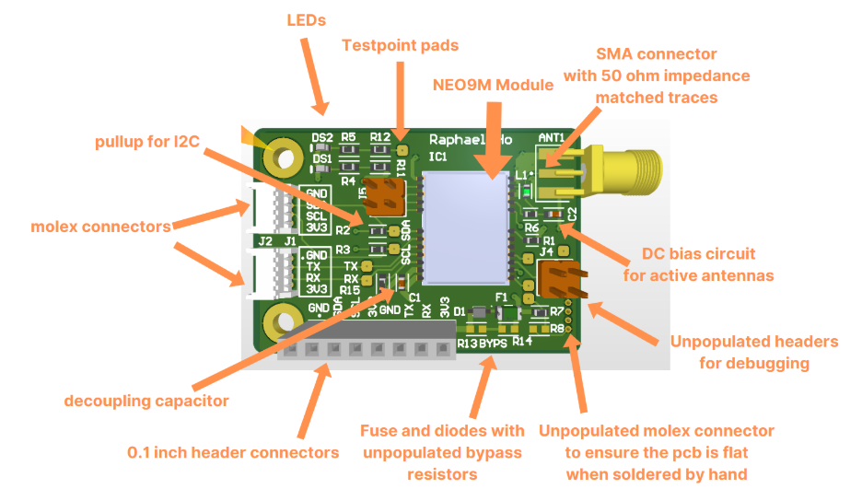
Figure 1. Annotated Diagram

Table 6. Specifications
Parameter | Min | Typical | Max | Unit | Notes
Voltage
Current
Weight
Connection Type:
Pinouts:
Communication protocols:
Example: 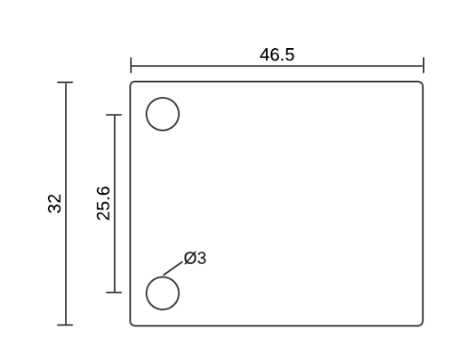
Figure 2. Mounting Footprint
Mounting recommendations
- Place on anti-static surface, ensure antenna is placed on top with clear view of sky etc

Hardware

Background
Any important background information to provide context to the reader should go here. This is topics like important technical backgrounds (i.e. what a Smitt chart is). Feel free to use sub-sub headings!

Overview
Explain how this design works, and how it will achieve your requirements. It doesn’t have to go down to a step by step level, but try and be specific as possible. Feel free to include block diagrams!

Design Assumptions
Table 9. Design Assumptions
Item | Notes

Components
Highlight any important components chosen in this section, and why. Only include if relevant. May be replaced with Library Selection if applicable to Software
Most passive components and connectors use fall under the Avionics Recommended Components document. You must mention anything that isn't a common component

Why did you choose an IC, what are its characteristics, anything you need to be aware of (maybe has an rf line, or can do a specific job)

Hardware Design V1
Highlight why this design has been chosen

Schematic design
PCB design
- Include the designs for PCBs, highlighting any important design choices. Only include if relevant
Include any relevant CAD designs, again documenting design choices. Only include if relevant

Hardware Design V2 (If required)

User Guide
Photo of PCB, setup – How do you setup the PCB so that you can use it safely
Anything to ensure that it works
Highlight any things that may go wrong with the design

Future changes
What will you do in the future, maybe for project v2?, others to investigate. Include anything that the testing document has recommended for a future design
Table 10. Future Changes
Item | Notes

Lessons Learnt
Include any lessons learnt in the testing document
Table 11. Lessons Learnt
Item | Notes

Appendix

References

